Use-Case Realization Report
Delete Lesson

Issue <1.0>
Revision History
Date | Issue | Description | Author
<dd/mmm/yy> | <x.x> | <details> | <name>

Table of Contents
1. Brief Description 4
2. Flow of Events 4
2.1 Standard Flow 4
2.2 Exception Flow 4
3. Interaction Diagrams 5
3.1 Collaboration Diagram for Delete Lesson 5
4. Participating Objects 5
5. Class Diagrams 6
5.1 Class Diagram for Delete Lesson 6
6. Derived Requirements 6

Use-Case Realization Report
Delete Lesson

Brief Description

Flow of Events

Standard Flow
- Portal Admin selects the lessons to be deleted, and click “delete” button
- Lesson Controller deletes the lessons selected.
- Lesson Controller deletes the lesson sections consisting of the deleted lessons.
- Lesson Controller updates the lesson modules, and mark the lessons deleted.

Exception Flow
  - If the lesson is in-use by some customers, i.e. one customer subscribes this lesson, and the subscription is still valid, an error message will popup to remind Portal Admin.

Interaction Diagrams

Collaboration Diagram for Delete Lesson
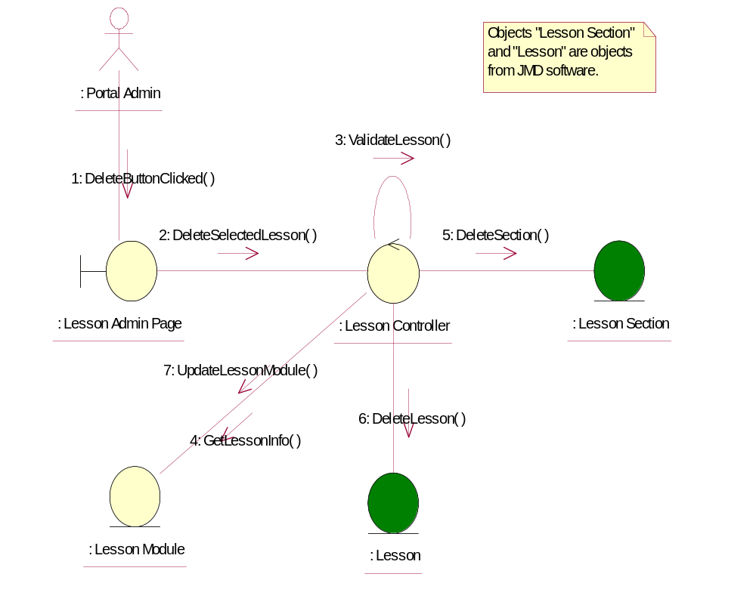

Participating Objects
: Lesson
This entity is the lesson object, it belongs to JMD.
: Lesson Admin Page
This is the page for adding, deleting, modifying lessons.
: Lesson Controller
This is the controller to upload, add, delete and modify lessons.
: Lesson Module
This is the object containing the lesson info.
: Lesson Section
This entity is the Section object, it belongs to JMD.
: Portal Admin
This is the super user of the system.

Class Diagrams

Class Diagram for Delete Lesson
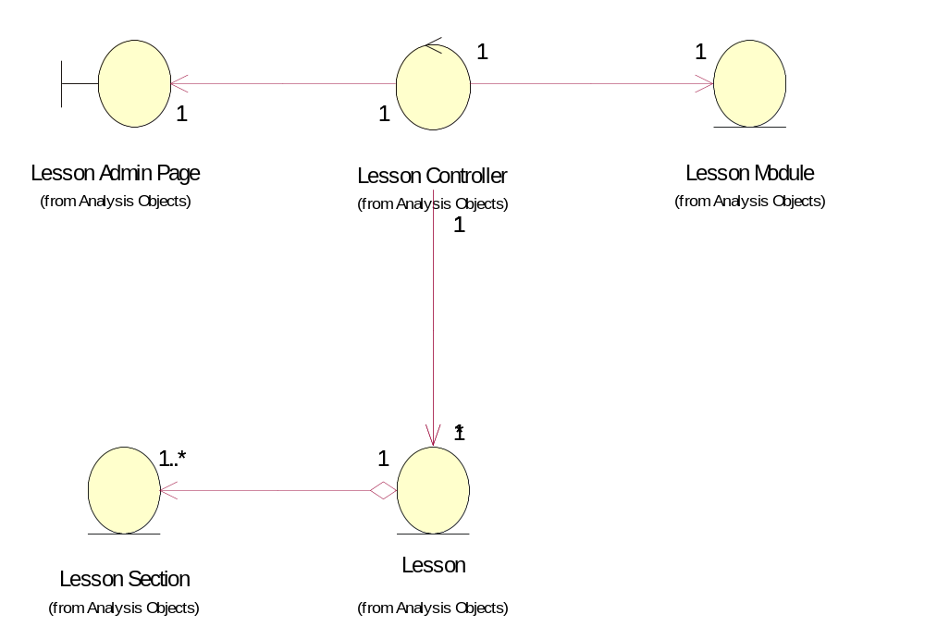

Derived Requirements
[enter the derived requirements here]

